MY Tag Table
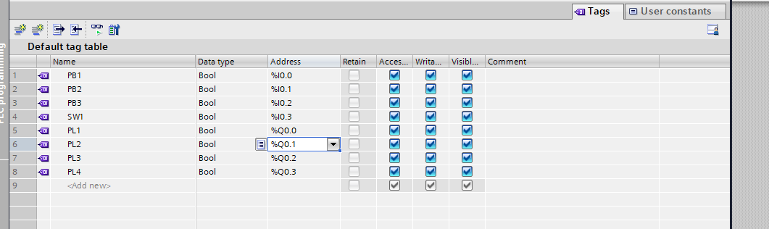

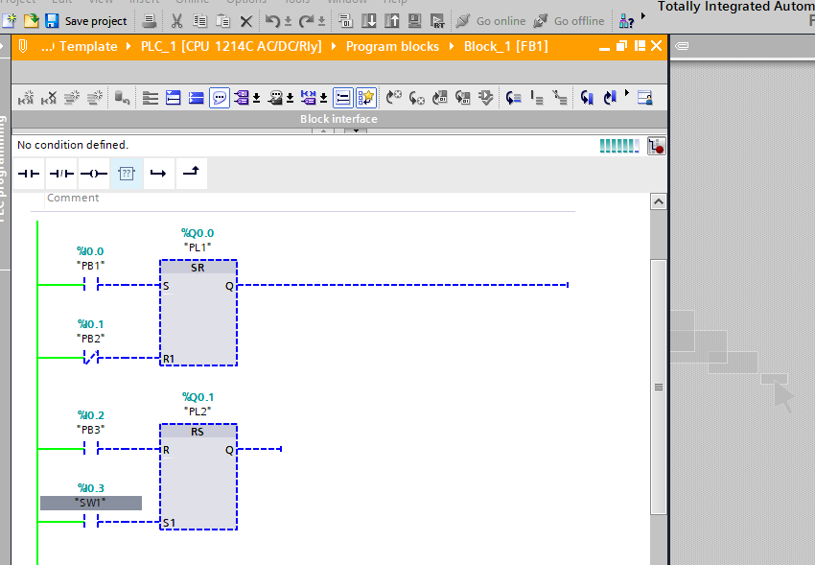
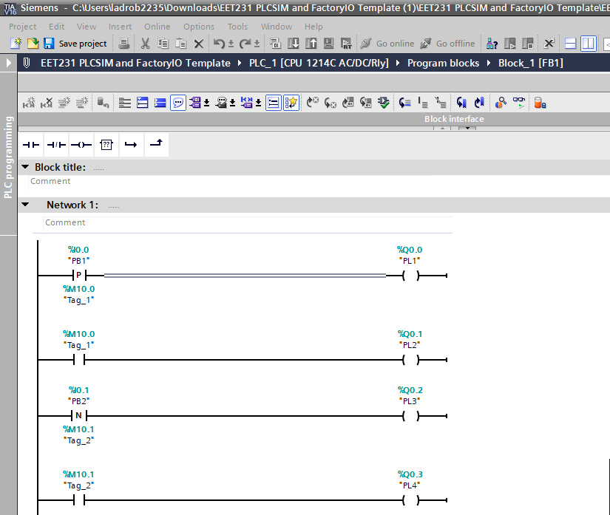
After PB2 was pushed PL3 lit momentarily and ended on the PL4
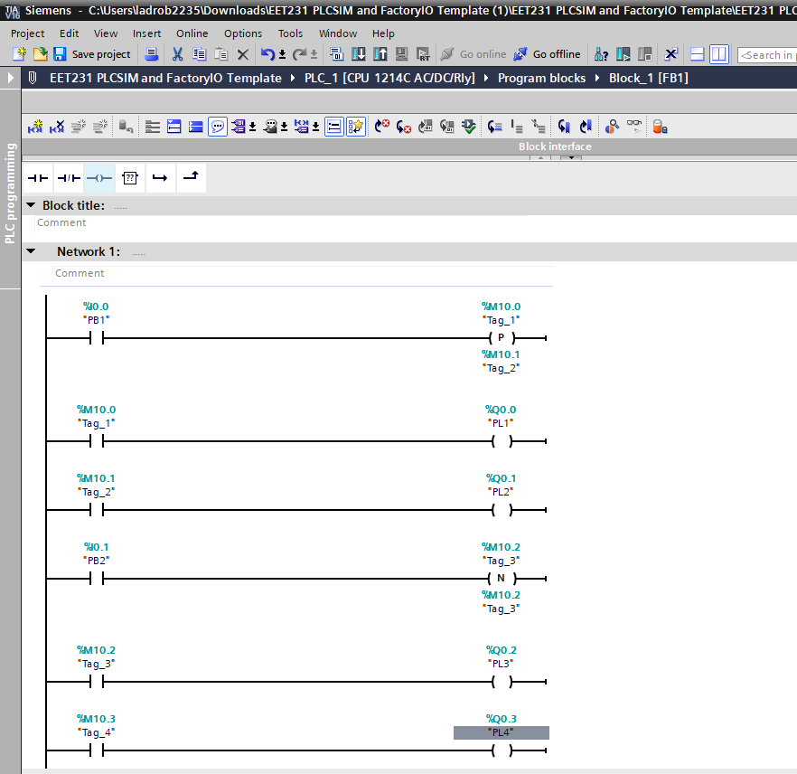
When Pb1 was pressed PL1 and PL2 were lit, however when PB2 pressed nothing happened.
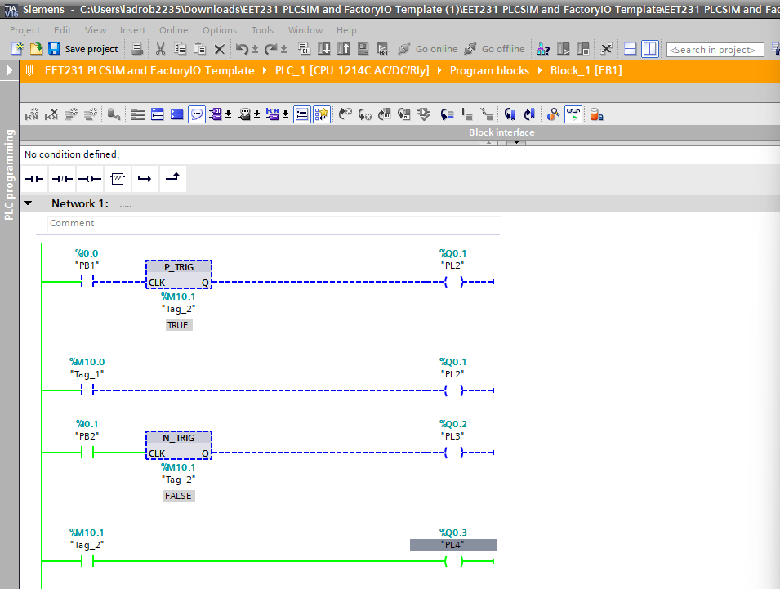
PB1 pushed and nothing happens and after PB2 pushed PL4 turns off
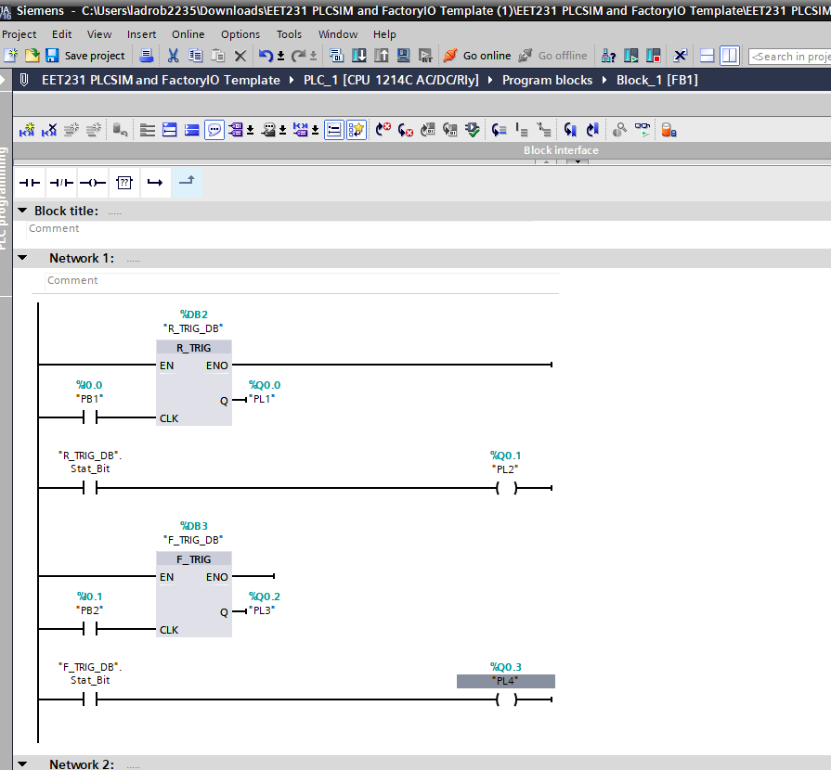
When PB1 pressed momentarily PL1 and 2 flashes on and then off
When PB2 pressed PL4 blinks off and PL3 blinks on
